

SVKM’S NMIMS
Mukesh Patel School of Technology Management and Engineering

Project Report

Course : Web Technologies (702IT0C038)

Name | Smit Vartak | Abheek Mahapatra | Sarthak  Vikas | Swara  Pawde
Roll No | K075 | K046 | K077 | K055
SAP ID | 70102500066 | 70102500021 | 70102500073 | 70102500037
Batch | K2 | K2 | K2 | K2

B.Tech.(Cybersecurity) Sem II

Faculty: Pratidnya S. Hegde Patil
Department of Information Technology

AY 2025-26
TABLE OF CONTENTS

Sr.No. | Topic | Page No
1. | Project Description and Comparison | 3
2. | Screen Shots of the Project with brief description of each screen shot | 6
3. | References | 9

Track & Trace: An OSINT CTF
This is our project for the Web Technologies subject in Semester 2. It is an OSINT CTF app made for people who have never tried CTFs before. We wanted to make it very simple so non-cybersecurity-related people can understand what OSINT is and how to find information online. While traditional CTFs often require complex Linux environments and command-line proficiency, this project bridges the gap by offering a seamless, browser-based experience focused on logic, investigation, and digital awareness.

Technologies used in this project were HTML, CSS, JavaScript, React, NodeJS, MySQL.

What are CTFs and OSINT?

CTF (Capture The Flag): A cybersecurity competition where participants solve challenges to find a hidden string or file called a "flag". You have to find the answers using appropriate tools and reach the objective the fastest.

OSINT (Open-Source Intelligence): The collection and analysis of data gathered from open sources (publicly available information) to produce actionable intelligence. In a CTF context, it means playing detective using public data scattered across the internet. In our case, you will be given a single image and have to solve 7 questions which lead from that single clue linearly.

“In an era of data transparency, awareness is your best firewall.”

This Project was designed to demonstrate how much information is publicly available and how easily it can be pieced together using perfectly legal, open-source resources. We encourage you to be mindful of your digital footprint, respect others' privacy, and always act responsibly. Stay safe online. This project is an educational tool. We believe that understanding how information is found is the first step toward securing it.

OUR GITHUB FOR THE PROJECT:

https://github.com/Aweek07/CTF_PROJECT
Setup

1. Download Prerequisites

- Install Node.js
- Install Official SQL download

2. Clone the Project

git clone https://github.com/Aweek07/CTF_PROJECT.git
cd CTF_PROJECT/ctf_proj

3. Install Dependencies

npm install
npm install mysql2

4. Import Answers into SQL server

you will have to run this in the previously used terminal which is open in the ctf_proj directory, and run the following command:

"C:\Program Files\MySQL\MySQL Server 8.0\bin\mysql.exe" -u root -p < setup.sql

5. Run the App

You will need two terminal windows open inside the ctf_proj folder:

Terminal 1 (Backend):

node server.js

Terminal 2 (Frontend):

npm start

The app will automatically open at http://localhost:3000

Why This CTF is Different (Comparison)

When we looked at existing platforms like TryHackMe or HackTheBox, we realized they’re amazing for professionals, but they can be incredibly intimidating for someone who just wants to learn the basics. Usually, you’re hit with a wall of "install this VM," "connect to this VPN," or "learn these 50 Linux commands" before you even find your first flag. For a lot of people, including our group members, that’s where the interest ends.
We wanted to change that. Track & Trace is our attempt to strip away the gatekeeping in cybersecurity.

What Makes This Project Special?

Zero Friction, Total Accessibility Most CTFs feel like a technical chore. Our project is designed to be a browser only experience. There’s no terminal to troubleshoot and no environment to break. By removing the heavy Linux requirements, we’ve made cybersecurity accessible to everyone. whether they’re a fellow engineering student or someone who has never touched a line of code. We believe that curiosity shouldn't be punished with a 2-hour installation guide (although ironically, to set it up you have to spend a while on installation).

The OSINT Approach Instead of focusing on obscure server vulnerabilities, our challenges are grounded in the digital world we actually live in. We focus on the Human Element, the photos we post, the metadata we leave behind, and the breadcrumbs we drop on social media. It’s not just about solving a puzzle… it makes the user realize, "Wait, if I can find this information about someone, what is someone finding out about me?"

Terminal-like feeling We intentionally kept clunky green text on black background aesthetic that most security tools use. We built a clean, intuitive, minimal and terminal-inspired interface that feels professional yet welcoming. We used React to ensure the experience is snappy and responsive, providing hints and feedback in real-time so the user never feels lost or stuck. There are no outside distractions.

Education as a Defence At its core, this isn't just a game… it’s a safety tool. By teaching people how to "Track & Trace" information legally and ethically, we’re actually teaching them how to secure their own lives. We’re turning passive internet users into active, digitally aware investigators. It’s about taking the mystery out of the dark web myths and showing that the most powerful tools are often just a browser and a bit of logic.
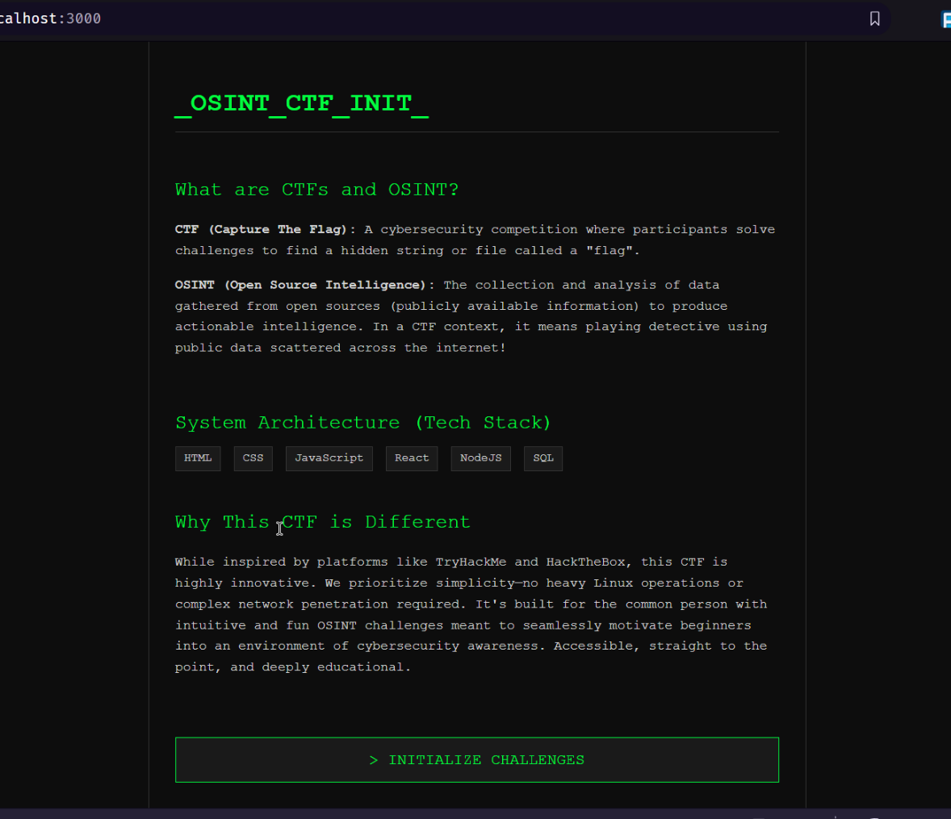
Screenshots with brief description.
1.Intro page (Intro.js):
This page briefs us with the purpose of this project. It is named as Intro.js inside the React app, acting as a gateway into the capture the flag challenge with [INITIALIZE CHALLENGE] button. This page describes the concepts of CTFs and OSINT which is needed to attempt this project. It is designed by keeping in mind that the challenge is going to be attempted by someone who is not familiar or not into cybersecurity.

This page also tells us the uniqueness of this project which might motivate the user to attempt the challenge and have an impact on their mindset about this field being only for enthusiasts.
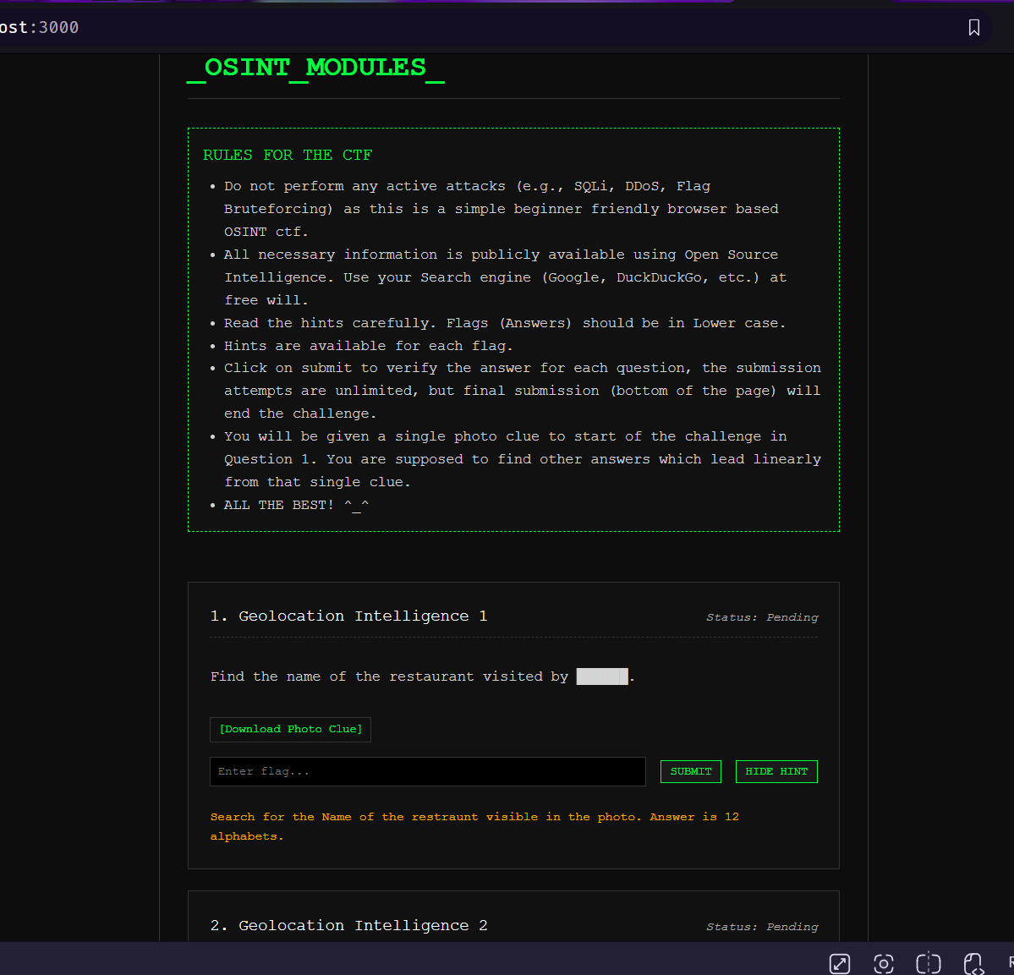

2. Main quiz page (Challenge.js):
This is the page where the CTF is attempted. The user will have to follow the instructions given on the top of this page. The user must use their OSINT capabilities (Mostly deductive reasoning and common sense) to find the flags. The user will have to input the answers through the first clue which can be downloaded by clicking on the hyperlink inside the first question. Hints can also be shown for each question if the user gets stuck or has no leads to follow. All the activities in this page will be timed as CTFs are time-based challenges. Clicking the final submit button on the bottom of this page will end the challenge and log all your answers.
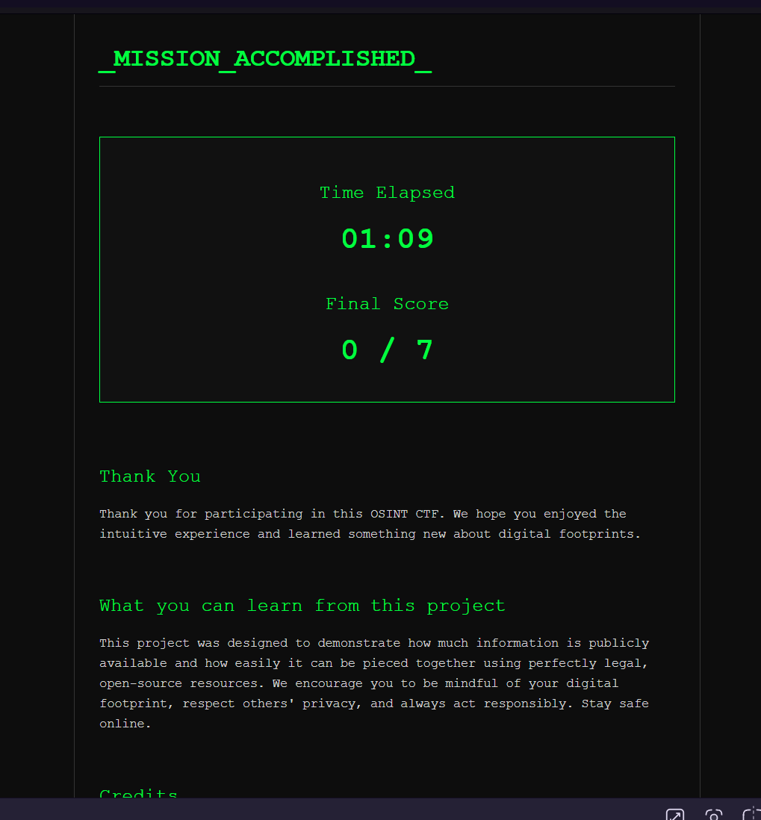
3. Final Result page (Endpage.js):
This is the page that appears after the challenge has been submitted. It consists of the time the user took to complete the challenge and the final score achieved by the user in this CTF. The format of the final score is such that it shows the number of questions the user was able to answer out of the total 7 questions. Not only does this page express gratitude to the user for attempting and completing the CTF, but also informs the user of what they can learn from this project.

References

Development Documentation & Tools:
- React Documentation: https://react.dev/ Used for building the component based UI and state management.
- Node.js API Reference: https://nodejs.org/en/docs/ Used for server side logic and database connectivity.
- MySQL Documentation: https://dev.mysql.com/doc/ Used for designing the relational schema and setup.sql configurations.
OSINT & Educational Resources:
- Bellingcat's Online Investigation Toolkit: A primary reference for real-world OSINT techniques.
- TryHackMe & HackTheBox: Analyzed as industry standards to identify gaps in beginner friendliness.
- GitHub Repository: https://github.com/Aweek07/CTF_PROJECT.git Source code and version control history for the Trace & Track project.

The stories amongst your group towards completion of the project which you don’t mind sharing with all.

We learnt Git and GitHub together as our collaborative platform and a tool to version-control, which honestly saved us quite a few times, by rolling back to a bug-free edition. We also found out that the technologies we learn in college are just basics, and sometimes depreciated syntaxes which are inefficient and bad practices which are frowned upon in this domain. We learnt a lot of new stuff which was too crucial to not be taught. This made us realise that learning through projects is the way to progress and not just college lectures.

Abheek’s PC would occasionally refuse to run SQL server and we had to debug and fix it for hours. Swara was not able to log into her old GitHub account and had to painstakingly recover it. Smit almost quit while coding since the SQL code was relatively new to us and had to learn it through its official documentation. Sarthak’s VS code was not running so he decided to download 100 extensions and it still couldn’t run.

